**CS 229, Fall 2018**

**Problem Set #3 Solutions:   
Deep Learning & Unsupervised learning**

1. **A Simple Neural Network**
2. Gradient w.r.t $w_{1,2}^{\left[1\right]}$.

Forward propagation:

$$z^{\left[1\right]}=W^{\left[1\right]}x^{\left(i\right)} \\ h=g\left(z^{\left[1\right]}\right) \\ z^{\left[2\right]}=W^{\left[2\right]}h \\ o^{\left(i\right)}=g\left(z^{\left[2\right]}\right)$$

Cost function:

$$l=\frac{1}{m}Σ_{i}^{m}{\left(o^{\left(i\right)}-y^{\left(i\right)}\right)}^{2}$$

Derivative of $W^{\left(2\right)}$ (Not needed in this problem).

$$\frac{∂l}{∂W^{\left[2\right]}}=\frac{∂}{∂W^{\left[2\right]}}{\left(o^{\left(i\right)}-y^{\left(i\right)}\right)}^{2} \\ =2\left(o^{\left(i\right)}-y^{\left(i\right)}\right)\frac{∂}{∂W^{\left[2\right]}}\left(g\left(z^{\left[2\right]}\right)\right) \\ =2\left(o^{\left(i\right)}-y^{\left(i\right)}\right)g\left(z^{\left[2\right]}\right) \left(1-g\left(z^{\left[2\right]}\right)\right)h \\ =2\left(o^{\left(i\right)}-y^{\left(i\right)}\right)o^{\left(i\right)}\left(1-o^{\left(i\right)}\right)h$$

Derivative of $W^{\left[1\right]}$

$$\frac{∂l}{∂W^{\left[1\right]}}=\frac{∂l}{∂o} \frac{∂o}{∂z^{\left[2\right]}}\frac{∂z^{\left[2\right]}}{∂h}\frac{∂h}{∂z^{\left[1\right]}}\frac{∂z^{\left[1\right]}}{∂W^{\left[1\right]}} \\ =2\left(o-y\right)o\left(1-o\right)W^{\left[2\right]}h\left(1-h\right)x$$

Add subscription and sum up

$$\frac{∂l}{∂W_{1,2}^{\left[1\right]}}=\frac{1}{m}\sum_{i=1}^{m}{2\left(o^{\left(i\right)}-y^{\left(i\right)}\right)o^{\left(i\right)}\left(1-o^{\left(i\right)}\right)W^{\left[2\right]}h_{2}\left(1-h_{2}\right)x^{\left(i\right)} }$$

1. In the dataset plot, find three points clock wise which can form a triangle to separate the dataset in two:

$$a^{\left(1\right)} = \left(0.5, 0.5\right) \\ a^{\left(2\right)} = \left(0.5, 3.5\right) \\ a^{\left(3\right)} = (3.5, 0.5)$$

Subtract with the next to form three vectors, and add intercept in front:

$$v^{\left(1\right)}= \left(0, -3.0\right) \\ v^{\left(2\right)}= \left(-3.0, 3.0\right) \\ v^{\left(3\right)}= \left(3.0, 0\right)$$

Equations for the above three vectors. For $v^{\left(1\right)}$ and $v^{\left(2\right)}$:

$$\frac{x_{1}-a_{1}^{\left(2\right)}}{v_{1}^{\left(1\right)}}=\frac{x_{2}-a_{2}^{\left(2\right)}}{v_{2}^{\left(1\right)}}$$

Which can re rewritten as:

$$v_{2}^{\left(1\right)}x_{1}-v_{1}^{\left(1\right)}x_{2}+\left(v_{1}^{\left(1\right)}a_{2}^{\left(2\right)}-v_{2}^{\left(1\right)}a_{1}^{\left(2\right)}\right)=0$$

This gives us the first component of matrix $W^{\left[1\right]}$:

$$W_{1}^{\left[1\right]}=\left(\begin{matrix}v_{2}^{\left(1\right)} \\ -v_{1}^{\left(1\right)} \\ v_{1}^{\left(1\right)}a_{2}^{\left(2\right)}-v_{2}^{\left(1\right)}a_{1}^{\left(2\right)}\end{matrix}\right)=\left(\begin{matrix}-3.0 \\ 0 \\ 1.5\end{matrix}\right)$$

Similarly, for $v^{\left(2\right)}$ and $v^{\left(3\right)}$ we have:

$$W_{2}^{\left[1\right]}=\left(\begin{matrix}v_{2}^{\left(2\right)} \\ -v_{1}^{\left(2\right)} \\ v_{1}^{\left(2\right)}a_{2}^{\left(3\right)}-v_{2}^{\left(2\right)}a_{1}^{\left(3\right)}\end{matrix}\right)=\left(\begin{matrix}3.0 \\ 3.0 \\ -12.0\end{matrix}\right)$$

And for $v^{\left(3\right)}$ and $v^{\left(1\right)}$ we have:

$$W_{3}^{\left[1\right]}=\left(\begin{matrix}v_{2}^{\left(3\right)} \\ -v_{1}^{\left(3\right)} \\ v_{1}^{\left(3\right)}a_{2}^{\left(1\right)}-v_{2}^{\left(3\right)}a_{1}^{\left(1\right)}\end{matrix}\right)=\left(\begin{matrix}0 \\ -3.0 \\ 1.5\end{matrix}\right)$$

Stack them to from a matrix $W^{\left[1\right]}$:

$$W^{\left[1\right]}=\left(\begin{matrix}-3.0 \\ 0 \\ 1.5\end{matrix}\begin{matrix}3.0 \\ 3.0 \\ -12.0\end{matrix}\begin{matrix}0 \\ -3.0 \\ 1.5\end{matrix}\right)$$

Explanation: given any point x, if its projection on the normal of vector $v^{\left(i\right)}$  is positive then it is on the right hand of $v^{\left(i\right)}$ , otherwise on the left. If it lies on the right of all the vectors, it is inside the triangle. (note the intercept is the last component of W which can be easily adjusted to be the first component)

Output layer matrix can be:

$$W^{\left[2\right]}=\left(\begin{matrix}-1 \\ -1 \\ -1 \\ 2.5\end{matrix}\right)$$

Because the input can only be one of the eight values of h:

$$h=\left(\begin{matrix}0/1 \\ 0/1 \\ 0/1 \\ 1\end{matrix}\right)$$

This guarantees that only for dataset inside the triangle could the product $W^{\left[2\right]}h$ be negative, which will then make f(x) = 0. All the other cases will have $W^{\left[2\right]}h≥0$, which makes f(x) = 1.

1. The activation function for $h_{1},h_{2},h_{3}$ is changed to $f\left(x\right)=x$, provide a set of weights that makes it achieve 100% accuracy.  
     
   Answer:  
   If the activation function is just f(x)=x, the NN is degraded to logistic regression. It is impossible to achieve 100% accuracy since the feature mappings doesn’t include high order components. The decision boundary is going to be a straight line and will have misclassification.
2. **KL divergence**

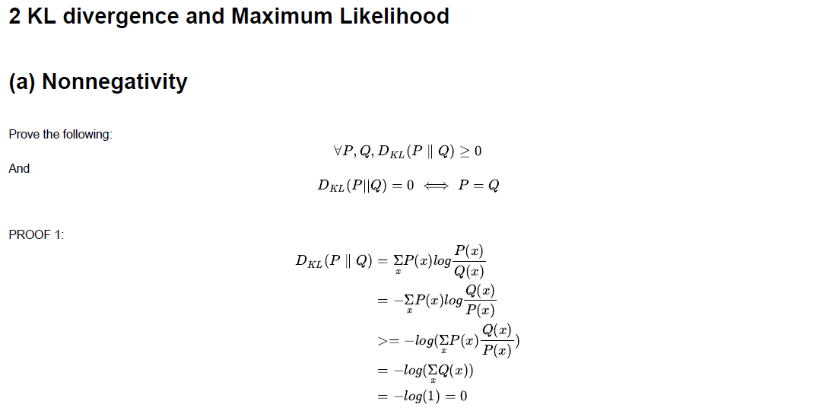

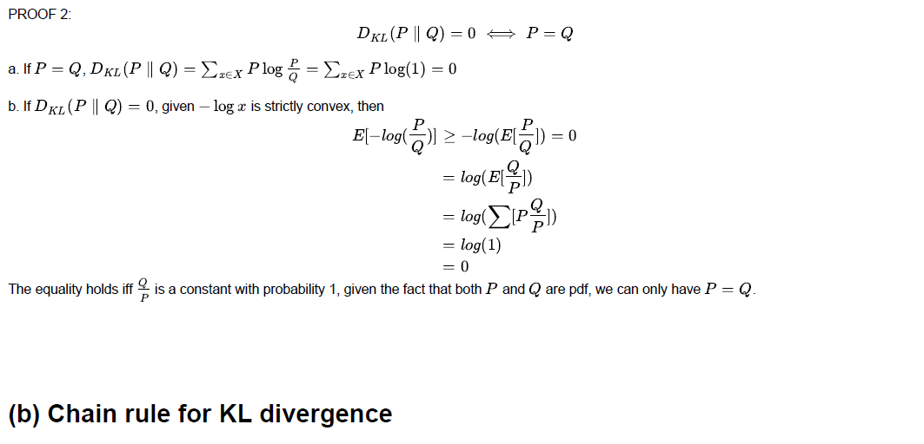

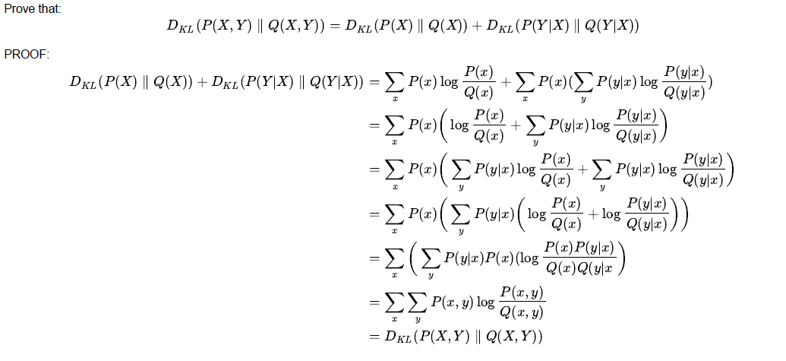



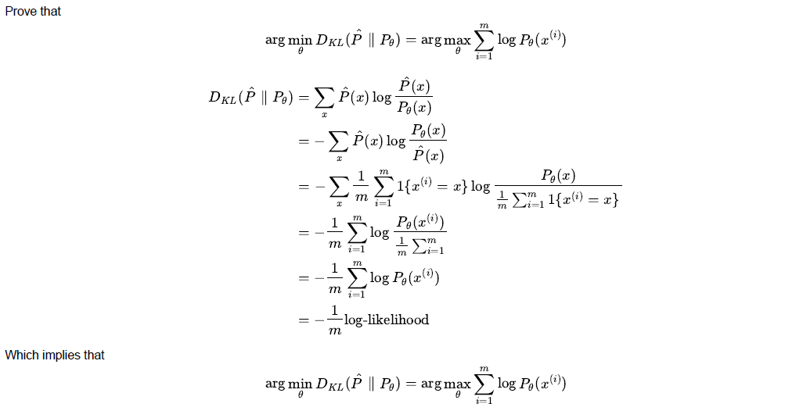

1. **KL divergence, Fisher Information, Natural gradient**

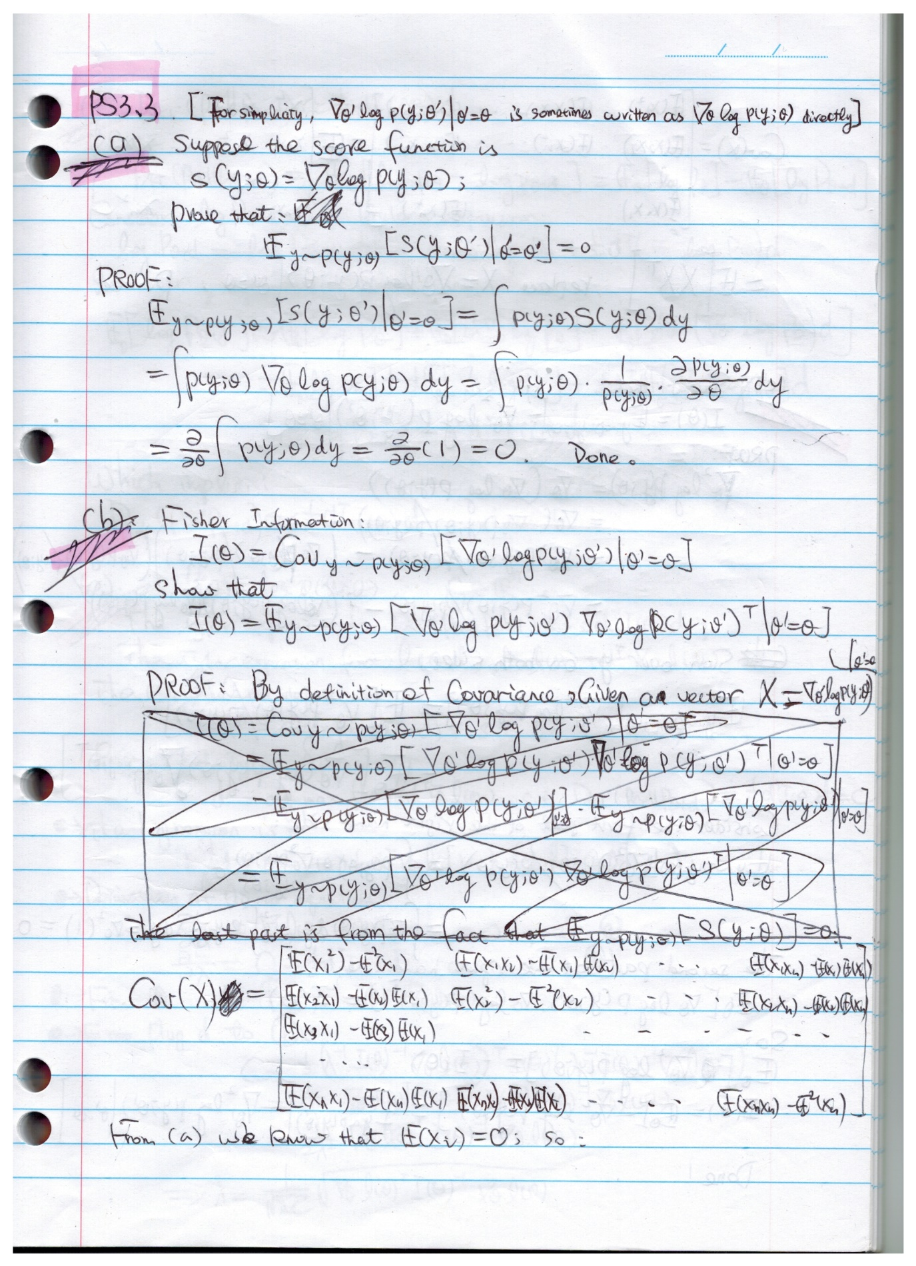

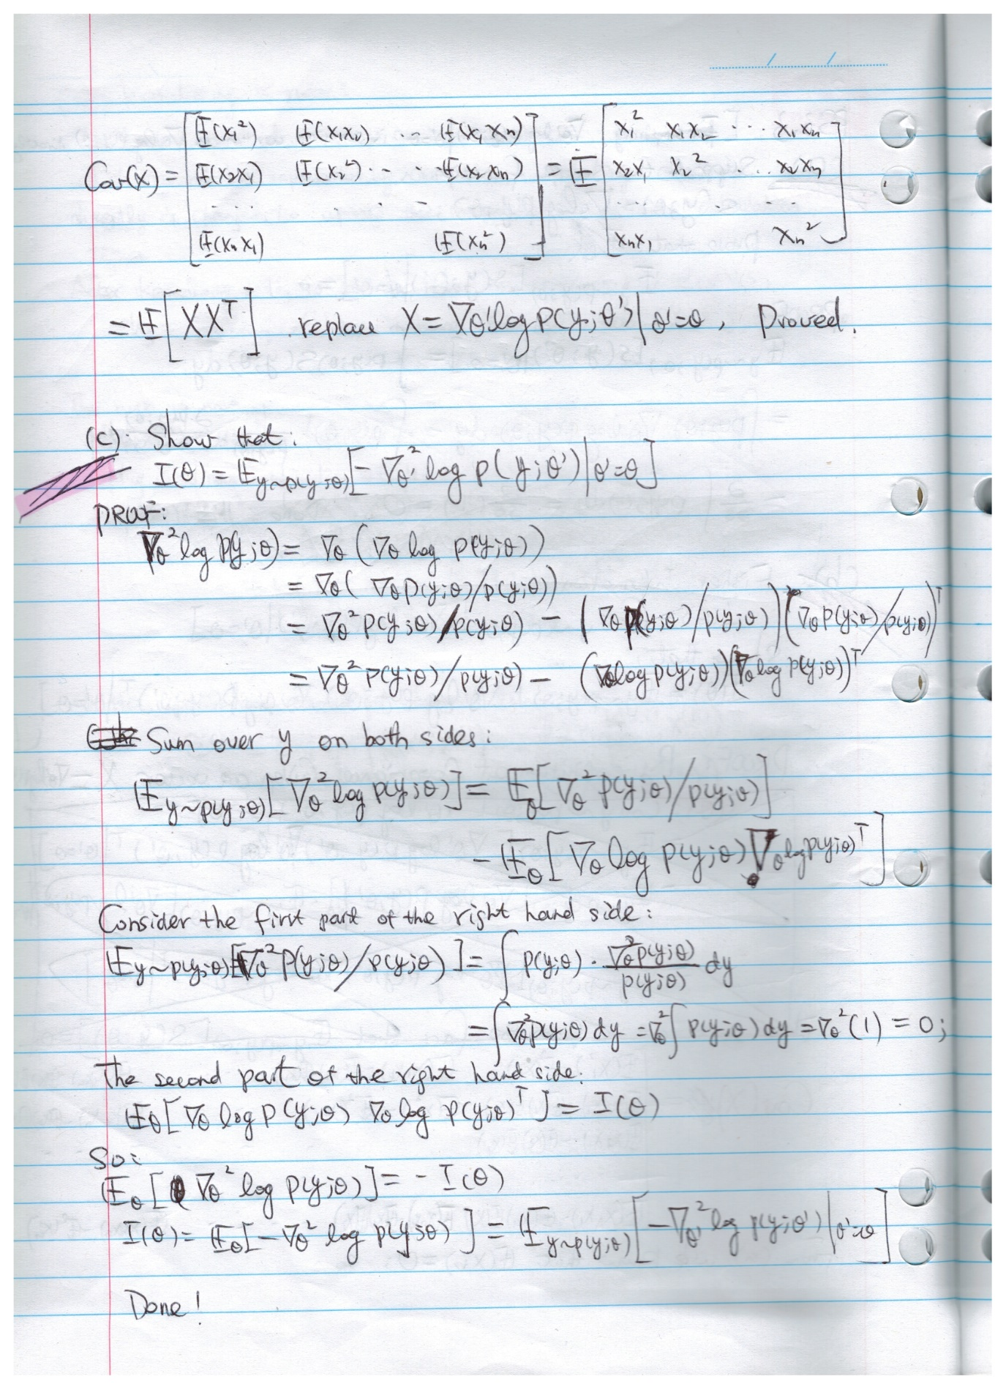

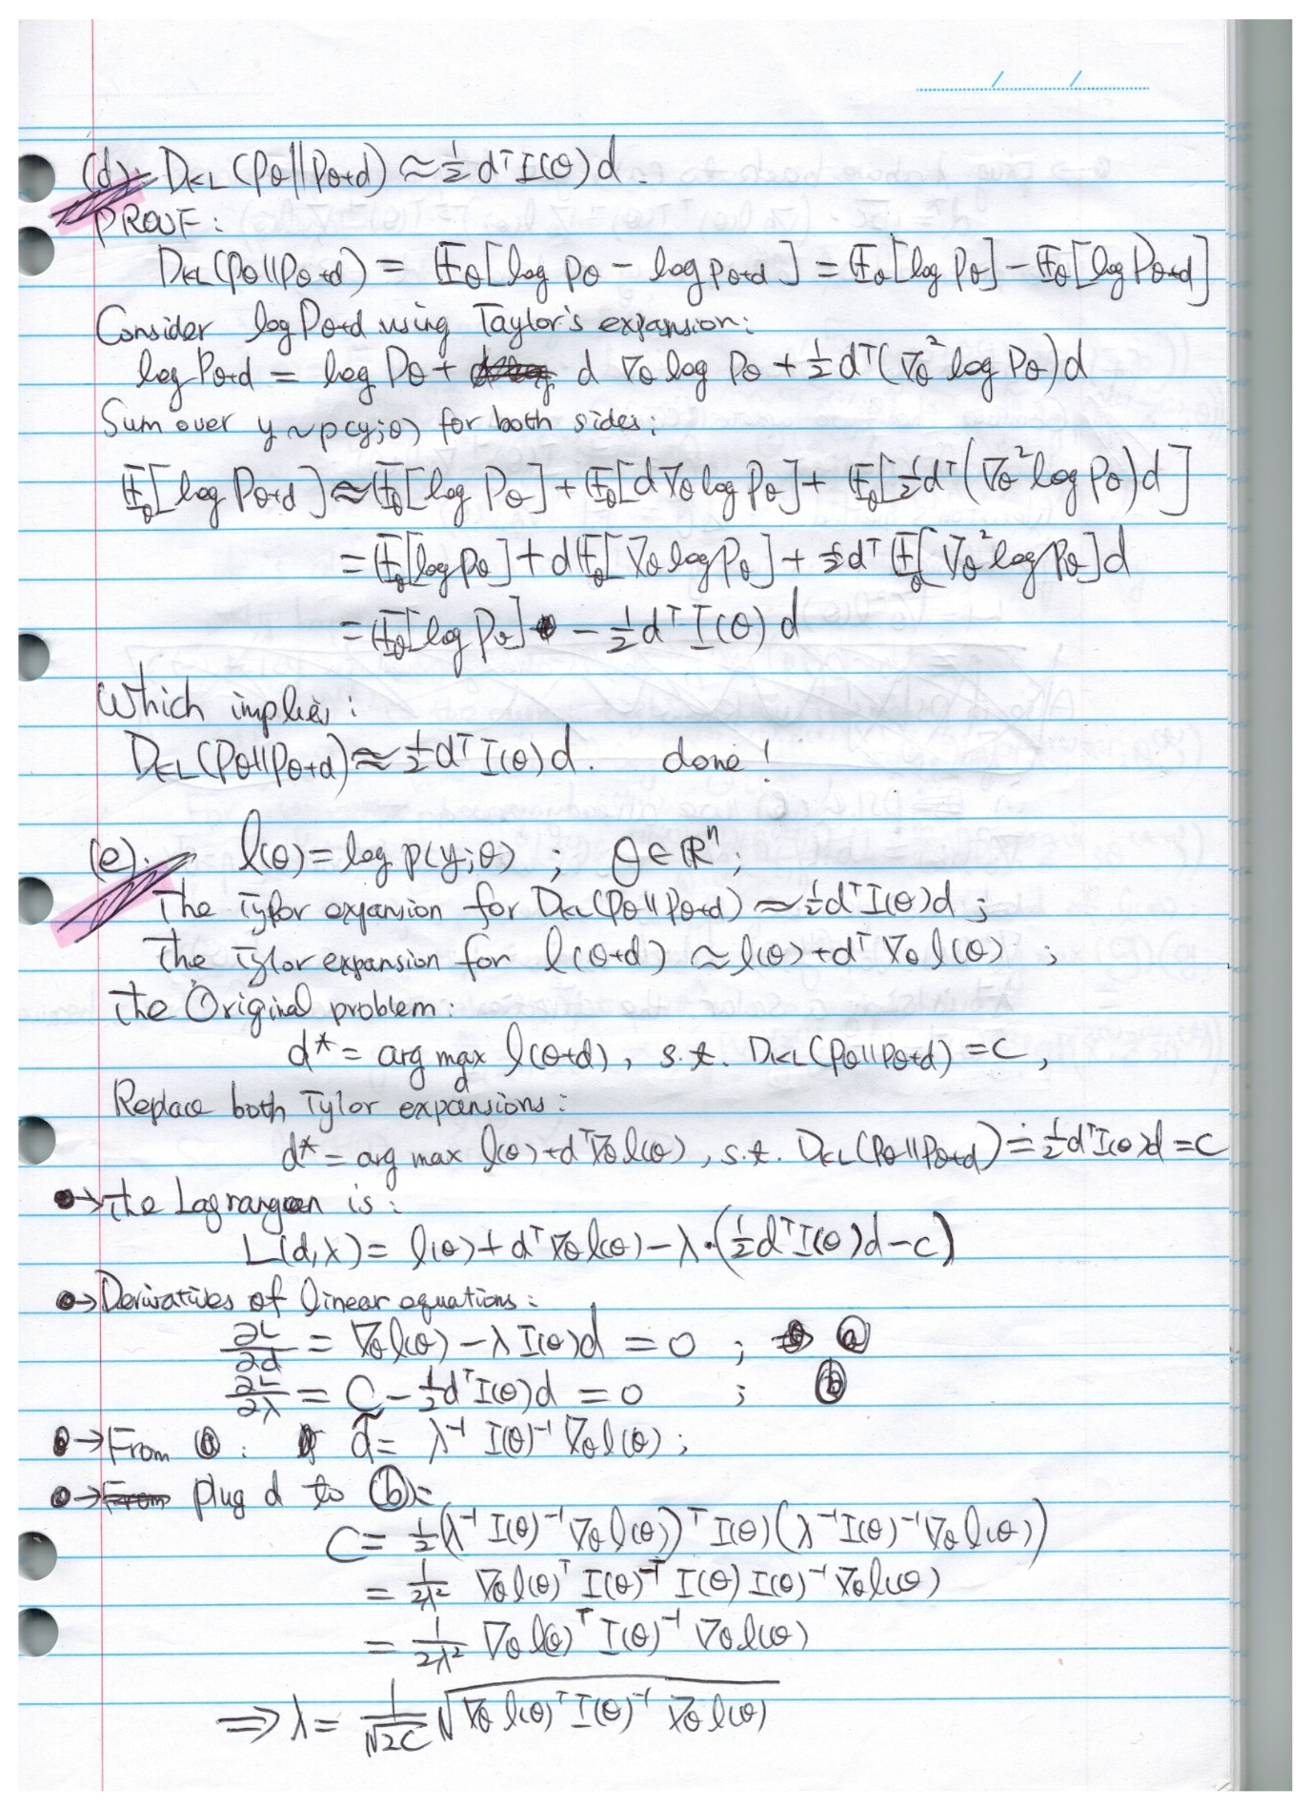

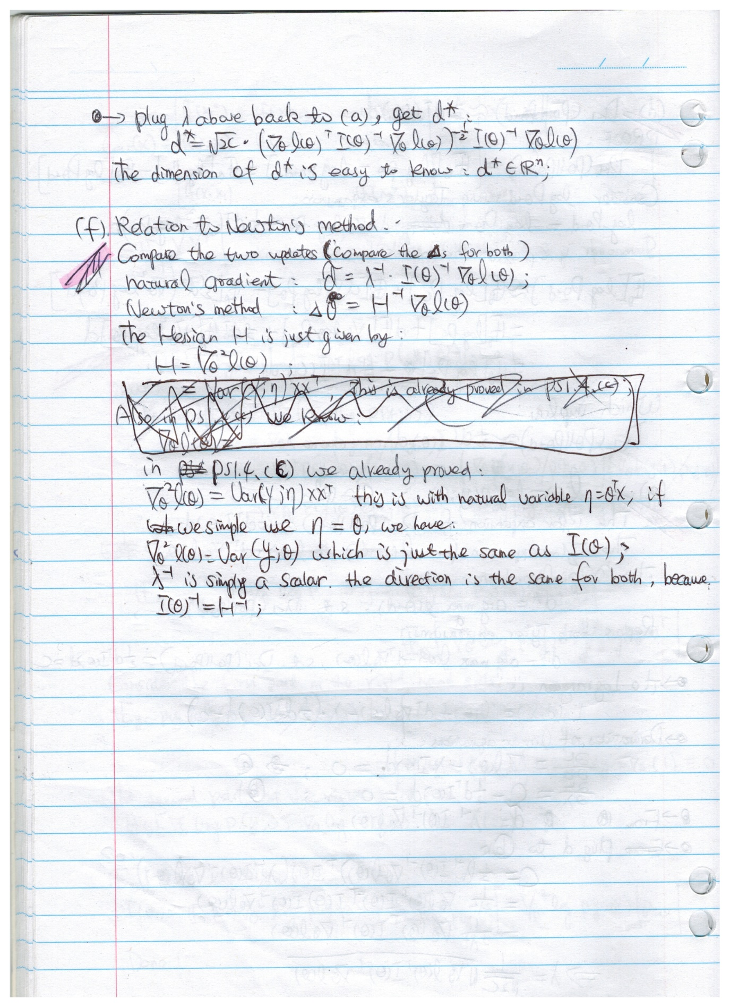

1. **Semi-supervised EM**

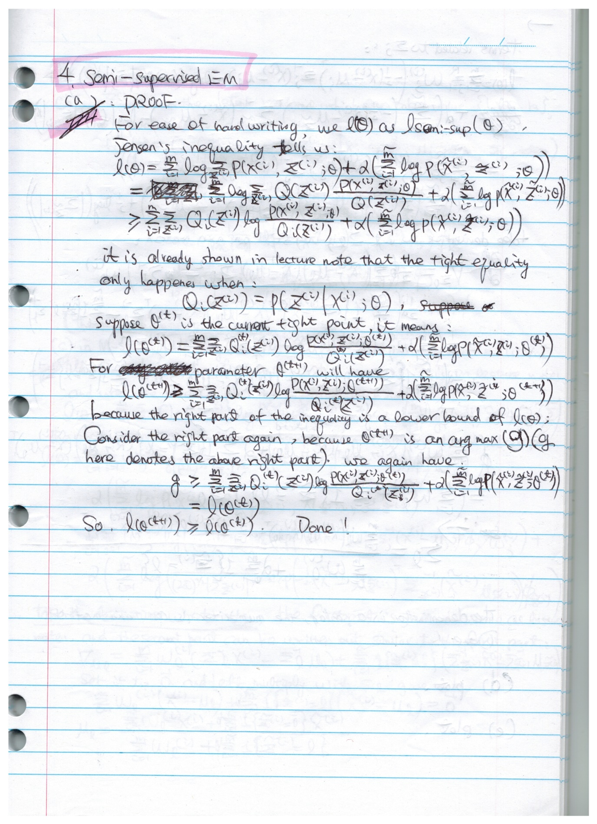

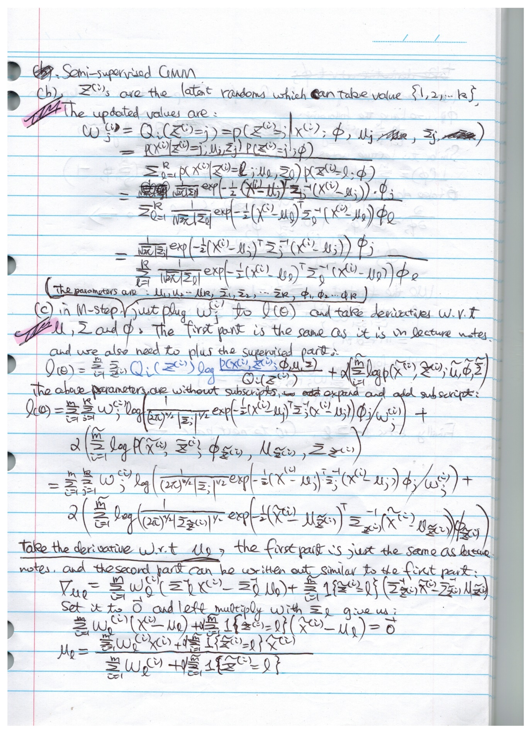

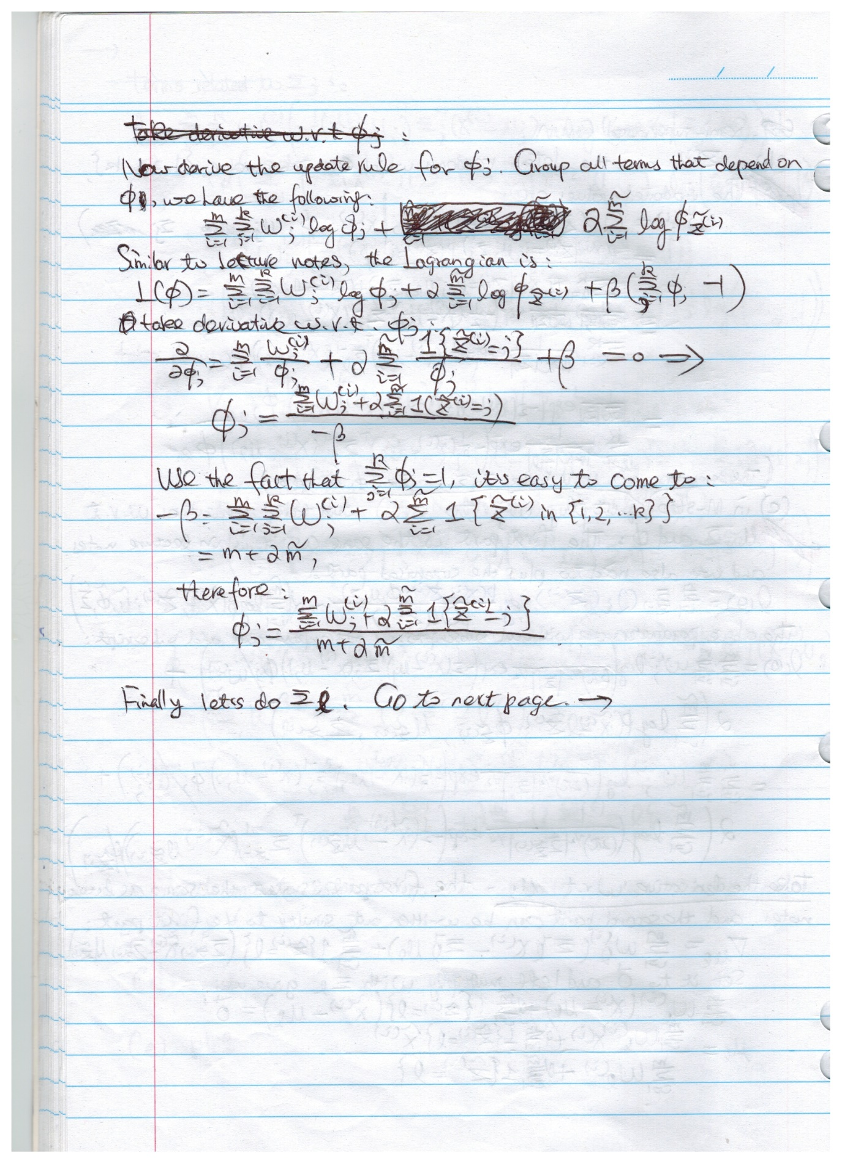

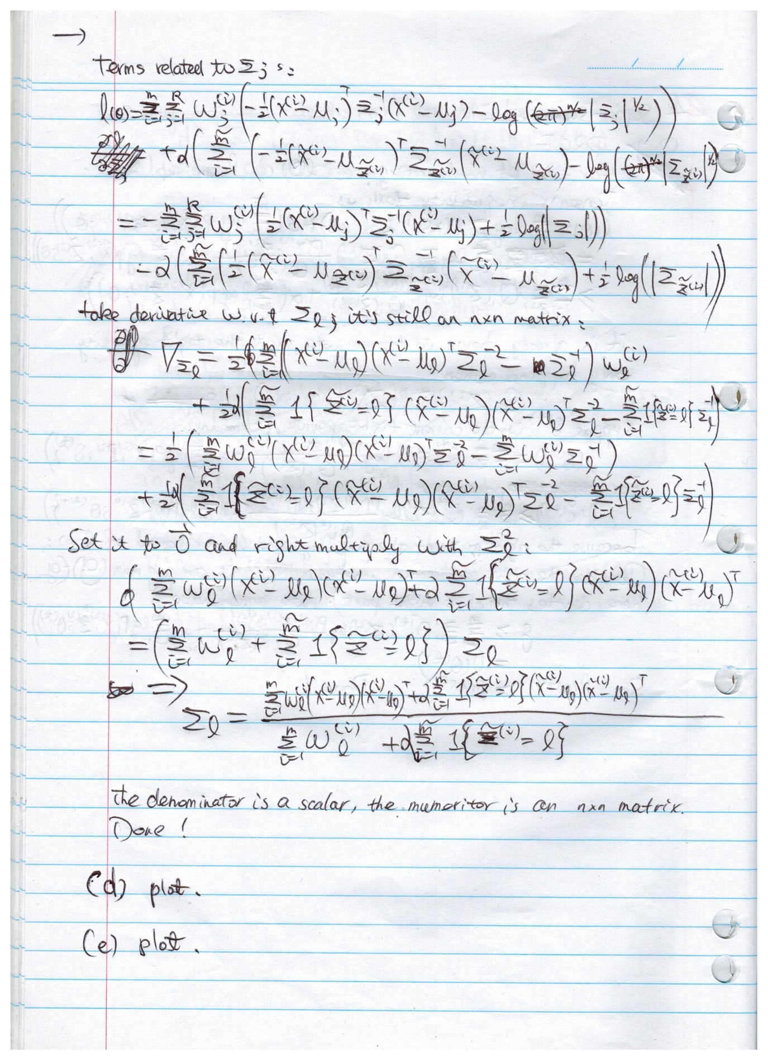

1. Unsupervised GMM predictions

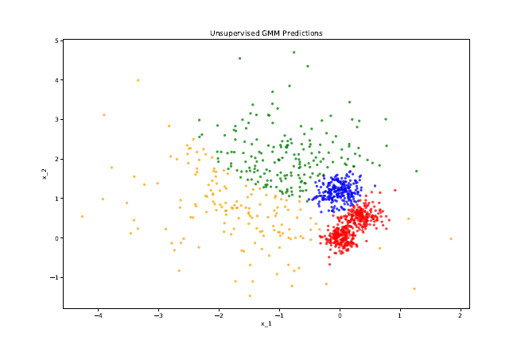

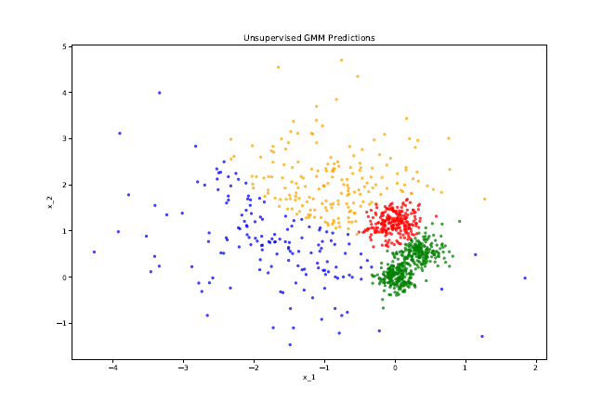

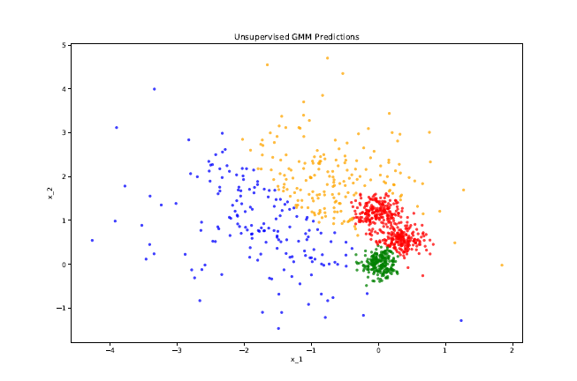

1. Semi-supervised GMM predictions:

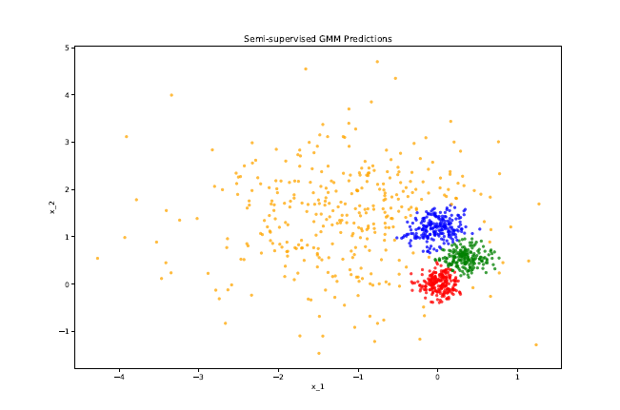

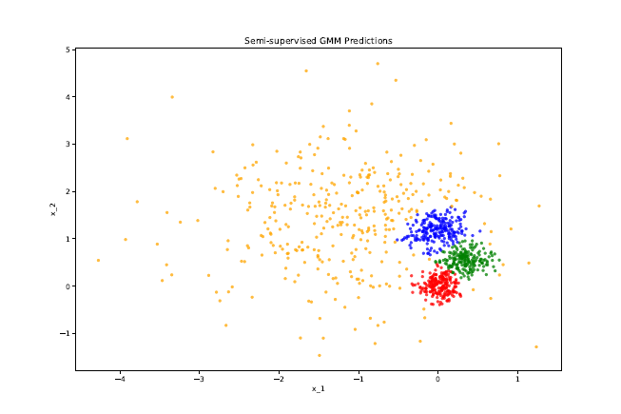

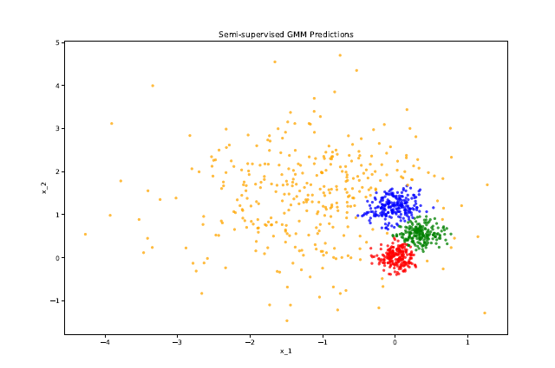

1. Comparison of Unsupervised and Semi-supervised EM
2. Number of iterations taken to converge  
   Answer:  
   Unsupervised EM takes 60 ~ 100 iterations to converge;   
   Semi-supervised EM only takes 20~30 iterations to converge.
3. Stability  
   Answer:  
   As can be seen in the above plot, Unsupervised EM is very sensitive to initialization and the class assignment changes dramatically with different random initializations.  
   Semi-supervised EM is very stable and class assignments do not change much.
4. Overall quality of assignments  
   Answer:  
   Overall the Semi-supervised EM has a much better quality compared to Unsupervised EM.
5. **K-means for compression.**
6. K-means compression implementation.

from matplotlib.image import imread

import matplotlib.pyplot as plt

import numpy as np

# reduce to n colors

def kmeans_compress(X, n = 16):

X = X.reshape(-1, 3)

centroids = X[np.random.choice(np.arange(X.shape[0]), size=n, replace=False)]

centers = np.zeros([n, 3])

#

while not np.array_equal(centers, centroids):

centers = centroids

norms = [np.sqrt(np.sum((centers[i] - X) ** 2, axis=1)) for

i in range(0, len(centers))]

idxs = np.stack(norms).argmin(axis=0)

#recalc centroids

centroids = np.array([np.mean(X[np.where(idxs == i,True,False)],

axis = 0).round() for i in range(n)])

#you need the data type conversion, otherwise you are in big trouble!!

return np.uint8(centroids), np.uint8(idxs)

def show_img(X, ax, s):

ax.imshow(X)

ax.set_title(s)

def main():

fig, axes = plt.subplots(2, 1, figsize=(12, 4))

axb1, axb2 = axes.ravel()

A1 = imread('..\data\peppers-small.tiff')

centroids,idxs = kmeans_compress(A1)

B1 = np.array([centroids[idxs[i]] for i in range(0, len(idxs))])

B1 = B1.reshape(A1.shape)

show_img(B1, axb1,'compressed peppers-small')

A2 = imread('..\data\peppers-large.tiff')

centroids,idxs = kmeans_compress(A2)

B2 = np.array([centroids[idxs[i]] for i in range(0, len(idxs))])

B2 = B2.reshape(A2.shape)

show_img(B2, axb2, 'compressed peppers-small')

plt.show()

if __name__ == '__main__':

main()

Compressed images:

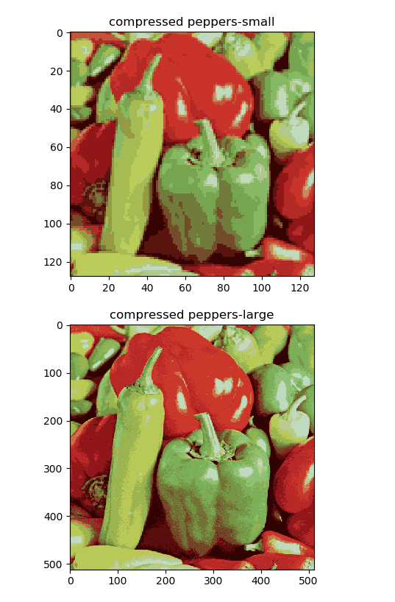

1. K-means compression Factor

Answer:

To store the original image, each pixel requires 24bit for the RGB value (255 x 255 x 255 colors);

To store the compressed image, each pixel will only need 16 colors, which need only 4bit storage.

The compression factor is thus 24:4 = 6:1.